17.66: Using the chain rule, 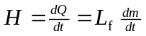and solving Eq. (17.21) for k,
